kane adams

Abstract

This is the documentation and written Development log for the remake of the Cookie Clicker game

Cookie Clicker

Game Development Documentation

Contents

What was done as part of an Assignment 2

The Game’s Design 2

Game Mechanics 2

Main Game Button 2

Buyable Upgrades 3

Reset Button 3

Plan for the Game (post-assignment) 4

Tasks I plan to complete 4

# What was done as part of an Assignment

The project was originally created as part of a university assignment in April 2020. For the assignment, we were to create remake of the cookie clicker game for Android. This was originally worked on by one programmer (me) and one designer, with a supervisor/client that told us what we should aim to complete.

## The Game’s Design

For our game, we decided to make it a fruit selling game where the player sells where the button should change into different fruit as you buy upgrades.

The designer created the 2D backgrounds for the main game screen and the shop screen, along with that, they created 3D models of fruit to use as buttons. I was to put the backgrounds and models into Unity, I was able to set the backgrounds but however had issues as turning the models into buttons.

## Game Mechanics

From what I was given as tasks to complete for this assignment, I was able to complete about half of them in the time given.

### Main Game Button

The player can click the big button on the main screen to increase the amount of money they earn; this can be done multiple times per frame. This can be seen when the at the bottom left next to the text saying “Balance”. For the mobile version, the automated pound symbol does not appear.

### Buyable Upgrades

I was able to create 5 buyable upgrades that can be brought at different prices, these upgrades level up (with there being a maximum level) and increase in price and impact the amount of income per second. If the player does not have enough money for the upgrade, the button will be faded and unable to be clicked. As extra, I began to implement buyable upgrades that change the amount of money the player earnt per click but had to comment out those buffs as time was limited.

### Reset Button

I was able to set up a reset button in the settings with a query to check whether you are sure you want to reset or that it was a mis-click. If you confirm that you want to reset, the upgrades will clear, and the balance will be put back to zero.

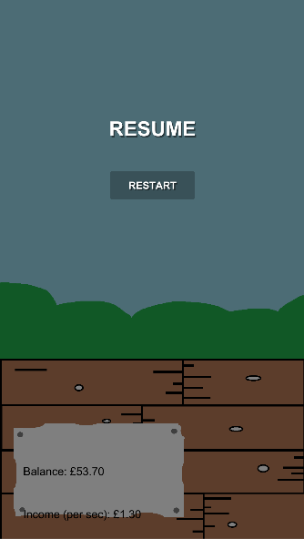 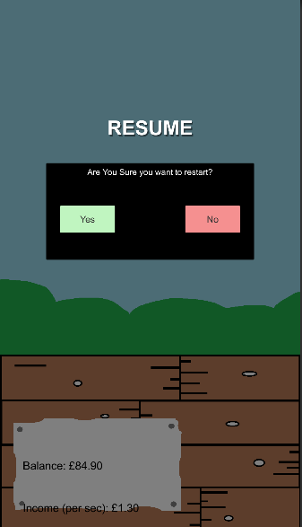

# Plan for the Game (post-assignment)

I plan to continue creating this game, fixing any issues there currently are with the game and then add extra features to it. I plan to do this because I want to use it to help me improve my experience with programming for Unity and to gain some skills in game design/art.

## Tasks I plan to complete

From looking at the stage the game is at now, I have planned on what I wish to complete and listed them as follows (order may change):

1. Fix resolution so it changes, depending on screen it is on
2. Add new tab for click multiplier upgrades (in shop)
   1. Add multiplier upgrades
3. Name the upgrades that are in the game
4. Add temporary upgrades
5. Add sound to the game
   1. Clicking sound for when player clicks on main game button
   2. Buying sound effect
6. Add sprites and animations
7. Save balance when the player leaves the game app
8. Change balance when the player returns to game (offline income)
9. Add a statistics system
   1. Show high score(s)
   2. Show current score(s)
10. Add more settings
    1. Add sound settings
    2. Add graphics setting